 | Student Name _______________________  Eastern Goldfields College  Unit 3 Essential Mathematics 2016  Mental Skills Test 2
 | Time: 10 minutes Total Marks: 50 marks
CALCULATORS NOT ALLOWED
1. Complete the formula:  Cos(θ) = | 9. 12m³ = L
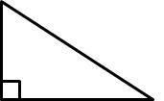  2. Calculate the value of x  x  6 m  8 m |   10. Calculate the area of this square in m²  0.1 km
3. Would you use Sin, Cos or Tan to solve for x?  x  12  30˚ | 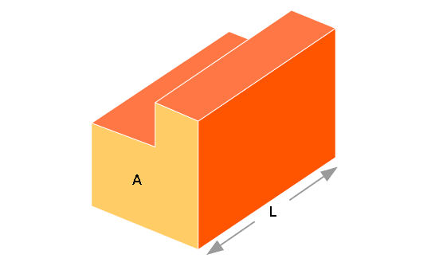  11. Draw a front elevation for this shape  FRONT
4. Name a real life application for a scale drawing | 12. How many faces does a pentagonal prism have?
5. Draw a plan for the shape from question 11. | 13. The Empire State building is 443m tall in real life but a scale drawing is 44.3cm. What was the scale used?
6. Calculate the value of x  x cm  5 cm  4 cm | 14. A map scale is 1 : 2000. How long in real life is a 5 cm line on the drawing?
7. Draw a possible net for a cube | 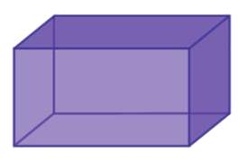  15. How many edges does this 3D shape have?
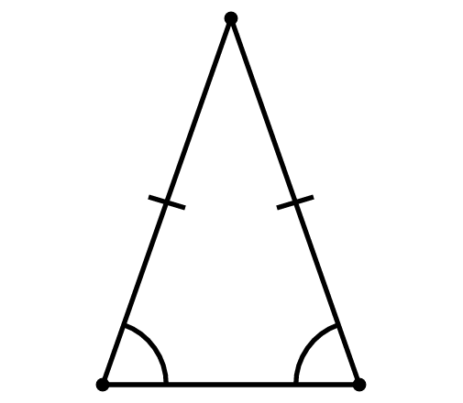
8. Name this type of triangle

